**Requirements Documentations for Starcom PPE Mercator Map 2.0**

**Folder Changes**

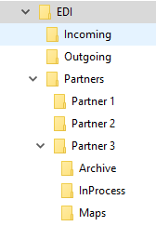

1. **EDI folder** is the root folder for all things EDI.
2. **Incoming folder** has all inbound EDI files coming into the client to be imported into PPE.
   1. Client may need to still rename file to **mail_in.new**.
   2. EDI applications or services may drop incoming EDI files in this directory, and they will have their own naming convention.
   3. Having a single incoming folder better enables PPE to monitor and automatically process inbound EDI data in the future.
   4. Having a single incoming folder is also better for EDI applications to keep track of just one folder to place all incoming EDI data.
   5. For example, some process can watch incoming folder, take each file, recognize the partner (HOMEDEPOT, LOWES, …) and be able to run the **partner inbound EDI** map such as **HDInbound.mmc, LWInbound.mmc**.
   6. If PPE cannot process files in Incoming folder for now, then the user can change the configuration file to point to a fixed location and file name such as **mail_in.new**.  The user must make sure that the incoming file is present as it is configured in the new configuration file, then run the **partner inbound EDI map.**
   7. We can’t have wildcard file name or path as it is a limitation of Mercator version Starcom distributes to customers, Mercator Event Server can handle wildcards but we don’t have that version.
3. **Outgoing folder** has all outgoing EDI files going out to the trading partners.
   1. Client may need to still rename file to **mail_out.new**.
   2. EDI applications or services may pick up outgoing EDI files in this directory, based on some file naming patter such as file extension, or some parts of file name that match a pattern to indicate it needs to work with.
   3. This folder has outgoing files with unique file names.
   4. Same benefits of having single outgoing folder as mentioned in incoming folder above.
4. **Partners folder** has one subfolder per trading partner.
5. Each partner folder has **Archive**, **InProcess** and **Maps** folders, specific to the trading partner.
   1. **Archive folder** has all inbound and outbound EDI and XML files processed, to be stored for archiving purpose.
   2. XML export files will be placed in each partner’s **InProcess** folder.  PPE can execute the outbound transaction map such as **Invoice.mmc, Shipment.mmc**, … and the map will place the outbound EDI file to the output file path (this is configurable via the new configuration file).
   3. **Maps folder** has all map execution files, or *.**mmc** files.

**Map Changes**

1. Each partner folder has **README file** which contains information:
   1. Each **README file** to contain date and version number
   2. List of artifacts in the folder
   3. List of input and output directories and file names
   4. Additional instructions documented for special mapping or EDI instructions

**Example of README File**

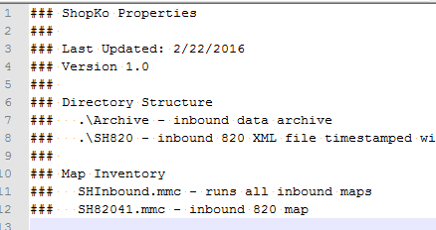

1. **New configuration** file is used instead of the **\*.INI** file.
   1. New format will provide more flexibility to store more configuration for both inbound and outbound.
   2. Only one configuration file is allowed per partner, and placed in the **partner** folder.
   3. Configuration file can have remarks to help users to know the instructions on how to update the configurations.

**Example of Configuration File**

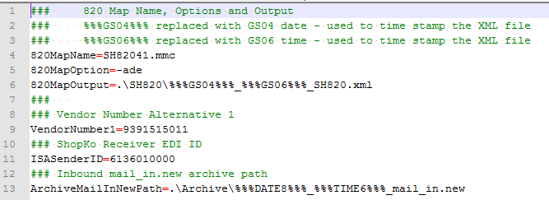

* 1. Configuration file can have **tokens** in file name and path. **Tokens** which get replaced with real values at runtime, such as adding current date time stamp, or globally unique serial number, in the file name, so we can guarantee uniqueness.
  2. Outbound file path can end with **+** to append to existing file. If the output file is already present, the map output is appended to the existing file.  If not present, a new file is created.  If output file name must be fixed such as **mail_out.new**, we can now append and not lose what’s already in that file.

1. Inbound maps will be updated.
   1. All partner maps will have one inbound map which triggers individual transaction maps.
   2. This avoids having to run each individual map.  We are currently doing this for Home Depot, Walmart and Kmart.
   3. Inbound EDI files are archived in partner specific Archive folder.
   4. Inbound maps are updated to use configuration file to know what path and file name to process, instead of always relying on hardcoded file name such as **mail_in.new.**

So for incoming folder, we can have files such as:

20160222_120000_HOMEDEPOT_850.TXT

20160222_120001_HOMEDEPOT_850.TXT

20160222_120002_LOWES_820.TXT

1. Outbound maps will be updated
   1. All outbound maps will use the new configuration file.
   2. Outbound maps will still have hard coded source file such as 810.xml, 855.xml, …
   3. PPE will invoke the outbound maps as it does currently.
   4. Outbound maps will be updated to produce unique path and file names when creating EDI files in the **Outgoing folder**, instead of hardcoding file name such as mail_out.new.
   5. Outbound maps will optionally make backup copy in the partner specific **Archive folder**.
2. For each source EDI file, only one type of 812 or 850 XML files is created.
   1. Within a single source file, there can be multiple interchanges and multiple transaction sets.
   2. All EDI 850 (or EDI 812) will be combined and mapped to one XML file.
   3. EDI 820 is an exception. For each interchange which always contains one transaction set, will produce one XML file. In another words, one check number produces one XML file.

**New Repository**

1. Archive all files in the new EDI folder to a GIT repository so that we can store history of revisions going forward.  David Flint already has created an account for Starcom.